Run 1:
- Accuracy LR Pre Oct 25: 0.5738255033557047
- Accuracy RF Pre Oct 25: 0.6185682326621924
- Accuracy of Models Initially Post Oct 25:
Training Set Model Performance Summary:
Model Accuracy
3 KNN 1.000000
2 Random Forest 1.000000
0 Logistic Regression 0.586573
1 Linear SVM 0.557483
4 Gaussian Naive Bayes 0.495105
5 Complement Naive Bayes 0.463217

Validation Set Model Performance Summary:
Model Accuracy
2 Random Forest 0.611857
3 KNN 0.573826
0 Logistic Regression 0.564877
1 Linear SVM 0.527964
4 Gaussian Naive Bayes 0.514541
5 Complement Naive Bayes 0.460850

- Model Errors:

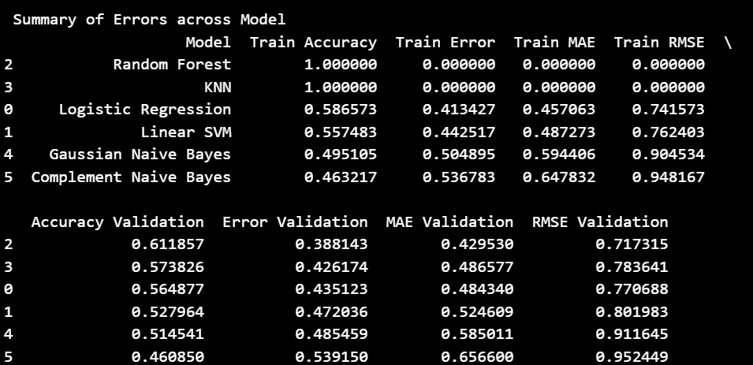

- Accuracy Optimal RF Post Oct 25:

These are the Best parameters found:
{'clf__bootstrap': True, 'clf__class_weight': 'balanced_subsample', 'clf__max_depth': 30, 'clf__max_features': 'sqrt', 'clf__min_samples_leaf': 2, 'clf__min_samples_split': 2, 'clf__n_estimators': 400}
Best CV Accuracy: 0.6193

Validation Accuracy (Best RF): 0.6174

- Optimal RF with additional FE:

Evaluating the Random Forest Model with feature engineering post train test split:
Accuracy is: 0.6174496644295302
Run 2:
- Accuracy LR Pre Oct 25: 0.5738255033557047
- Accuracy RF Pre Oct 25: 0.6185682326621924
- Accuracy of Models Initially Post Oct 25:
Training Set Model Performance Summary:
Model Accuracy
3 KNN 1.000000
2 Random Forest 1.000000
0 Logistic Regression 0.584615
1 Linear SVM 0.557483
4 Gaussian Naive Bayes 0.495105
5 Complement Naive Bayes 0.463217

Validation Set Model Performance Summary:
Model Accuracy
2 Random Forest 0.611857
3 KNN 0.573826
0 Logistic Regression 0.563758
1 Linear SVM 0.527964
4 Gaussian Naive Bayes 0.514541
5 Complement Naive Bayes 0.460850

- Model Errors:
Calculating errors for this model Random Forest...

Calculating errors for this model KNN...

Calculating errors for this model Gaussian Naive Bayes...

Calculating errors for this model Complement Naive Bayes...

Summary of Errors across Model
Model Train Accuracy Train Error Train MAE Train RMSE \
2 Random Forest 1.000000 0.000000 0.000000 0.000000
3 KNN 1.000000 0.000000 0.000000 0.000000
0 Logistic Regression 0.584615 0.415385 0.457063 0.739306
1 Linear SVM 0.557483 0.442517 0.487273 0.762403
4 Gaussian Naive Bayes 0.495105 0.504895 0.594406 0.904534
5 Complement Naive Bayes 0.463217 0.536783 0.647832 0.948167

Accuracy Validation Error Validation MAE Validation RMSE Validation
2 0.611857 0.388143 0.429530 0.717315
3 0.573826 0.426174 0.486577 0.783641
0 0.563758 0.436242 0.485459 0.771413
1 0.527964 0.472036 0.524609 0.801983
4 0.514541 0.485459 0.585011 0.911645
5 0.460850 0.539150 0.656600 0.952449

- Accuracy Optimal RF Post Oct 25:

These are the Best parameters found:
{'clf__bootstrap': True, 'clf__class_weight': 'balanced_subsample', 'clf__max_depth': 30, 'clf__max_features': 'sqrt', 'clf__min_samples_leaf': 2, 'clf__min_samples_split': 2, 'clf__n_estimators': 400}
Best CV Accuracy: 0.6193

Validation Accuracy (Best RF): 0.6174

- Optimal RF with additional FE:
Evaluating the Random Forest Model with feature engineering post train test split:
Accuracy is: 0.6174496644295302
Run 3:
- Accuracy LR Pre Oct 25: 0.5738255033557047
- Accuracy RF Pre Oct 25: 0.6185682326621924
- Accuracy of Models Initially Post Oct 25:
Training Set Model Performance Summary:
Model Accuracy
3 KNN 1.000000
2 Random Forest 1.000000
0 Logistic Regression 0.584615
1 Linear SVM 0.557483
4 Gaussian Naive Bayes 0.495105
5 Complement Naive Bayes 0.463217

Validation Set Model Performance Summary:
Model Accuracy
2 Random Forest 0.611857
3 KNN 0.573826
0 Logistic Regression 0.563758
1 Linear SVM 0.527964
4 Gaussian Naive Bayes 0.514541
5 Complement Naive Bayes 0.460850

- Model Errors:
Summary of Errors across Model
Model Train Accuracy Train Error Train MAE Train RMSE \
2 Random Forest 1.000000 0.000000 0.000000 0.000000
3 KNN 1.000000 0.000000 0.000000 0.000000
0 Logistic Regression 0.584615 0.415385 0.457063 0.739306
1 Linear SVM 0.557483 0.442517 0.487273 0.762403
4 Gaussian Naive Bayes 0.495105 0.504895 0.594406 0.904534
5 Complement Naive Bayes 0.463217 0.536783 0.647832 0.948167

Accuracy Validation Error Validation MAE Validation RMSE Validation
2 0.611857 0.388143 0.429530 0.717315
3 0.573826 0.426174 0.486577 0.783641
0 0.563758 0.436242 0.485459 0.771413
1 0.527964 0.472036 0.524609 0.801983
4 0.514541 0.485459 0.585011 0.911645
5 0.460850 0.539150 0.656600 0.952449

- Accuracy Optimal RF Post Oct 25:

These are the Best parameters found:
{'clf__bootstrap': True, 'clf__class_weight': 'balanced_subsample', 'clf__max_depth': 30, 'clf__max_features': 'sqrt', 'clf__min_samples_leaf': 2, 'clf__min_samples_split': 2, 'clf__n_estimators': 400}
Best CV Accuracy: 0.6193

Validation Accuracy (Best RF): 0.6174

- Optimal RF with additional FE:

Evaluating the Random Forest Model with feature engineering post train test split:
Accuracy is: 0.6174496644295302

